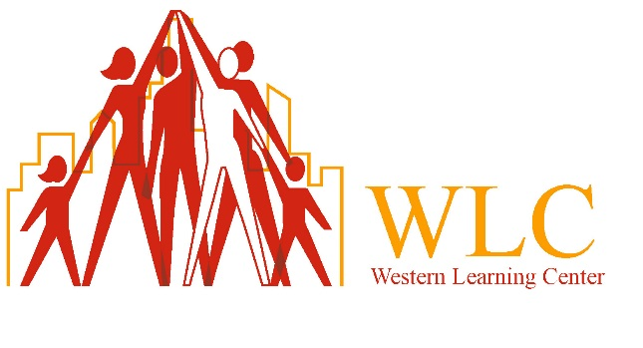
1613 South Street
Philadelphia, PA. 19146
215.735.1261
Pre-Application
___ Early Learning Center ___ Out Of School Time/Afterschool
Today’s Date: __________________________
Child’s Name: __________________________ Date of Birth: _________ Grade: __________
Additional Children: ______________________________ ________________________________
Parent/Guardian Name: _____________________________________________________________
Address: ________________________________________________________________________
City: ___________________________________ State: _______________________________
Phone Number: ________________________ Email: _______________________________
How did you hear about us? _________________________________________________________
Thank you for your interest in Western Learning Center, someone from our Intake Department will be in contact with you within 48 hours.
Items needed for face to face intake interview:
- Health Assessment
- Birth Certificate
- Social Security Card
- Address Verification

